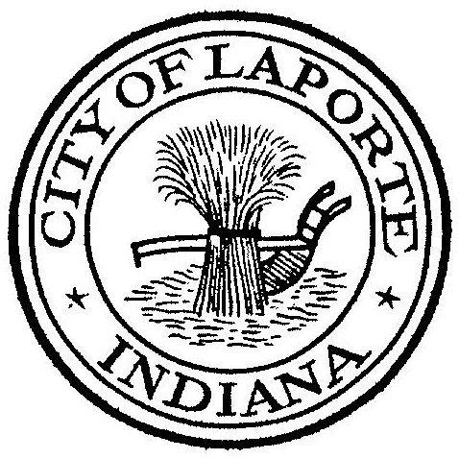
Board of Public Works and Safety
Jessica Romine, Member Tom Dermody, Mayor Mark Kosior, Member
City Hall 801 Michigan Ave., La Porte, IN 46350
Wednesday, June 21, 2023
9:00 AM
AGENDA
- Call To Order
- Pledge Of Allegiance
- Approval Of Minutes
- Public Comment: In Person and via Facebook Live
- Clerk-Treasurer: Claims Approval
- Department Head Reports
- New Business:
-Request for Use: O’Reilly Car Show
Graduation Celebration
-Real Estate Purchase: 910 State Street
-Beth West: La Porte Fund Conveyance Agreement
-Paul Brettin: LPPD Durango vs Charger
8) Unfinished Business:
9) Other Business: Next regularly scheduled meeting: Thursday, July 6, 2023 at 9a
10) Adjourn

